**Odisha**

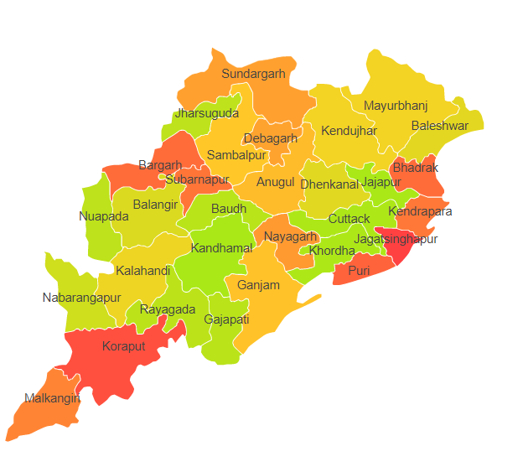

Odisha comprises of two Agro Ecological Regions (AER) 12 & 18.

**Agro-Eco Region 12:** AER 12 in Odisha comprises of Anugul, Balangir, Baleshwar, Baragarh, Bauda, Bhadrak, Cuttack, Deogarh, Dhenkanal, Gajapathi, Ganjam, Jharsuguda, Jajapur, Kalahandi, Kandhamal, Kendujhar, Khordha, Koraput, Malkangiri, Mayurbhanj, Nabarangapur, Nayagarh, Nuapadha, Rayagarha, Sambalpur, Subarnapur and Sundargarh districts of Eastern (Chhotanagpnr) Plateau and Eastern Ghats under Agro Ecological Sub Regions (AESR) 12.1,12.2 & 12.3.

**Agro-Eco Region 18:** AER 18 in Odisha comprises of Baleshwar, Ganjam, Jagatsinghapur, Kendraparha, Khordha and Puri districts of Eastern Coastal Plains under Agro Ecological Sub Regions (AESR) 18.4 & 18.5.